Cookie Moon Phases
The moon fully orbits around Earth about once every month. During its orbit, we can see the moon in different phases. The phases are controlled by the amount of sunlight reflected off the moon that we can see from Earth at any point during its orbit.
You Will Need:
- 8 Oreo Cookies
- A popsicle stick or other tool for scraping the frosting

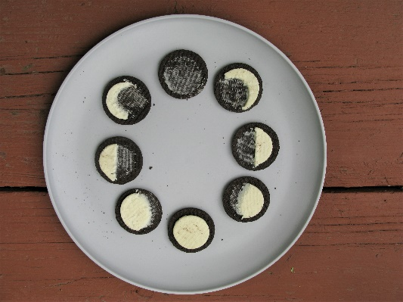
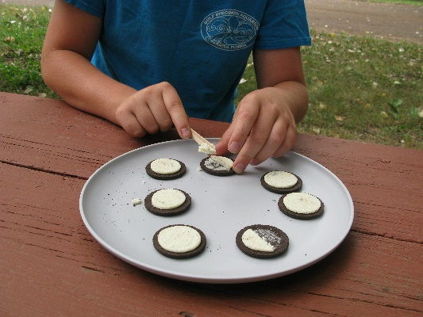
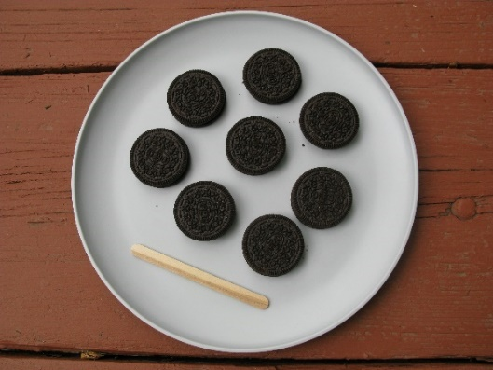

What to Do:
- Slowly twist an Oreo open to leave as much frosting on one side of the cookie as possible. If it doesn’t work, eat the cookie and try again!
- Use the popsicle stick or scraper to create the phases of the moon out of the frosting.
- Arrange the phases of the moon in order.

This model is a great visual representation of a simple cycle of the phases of the moon. To better visualize the phases of the moon, you may place an object in the center of the moon phase circle and place another object on the outside of the moon phase circle to represent the sun.

